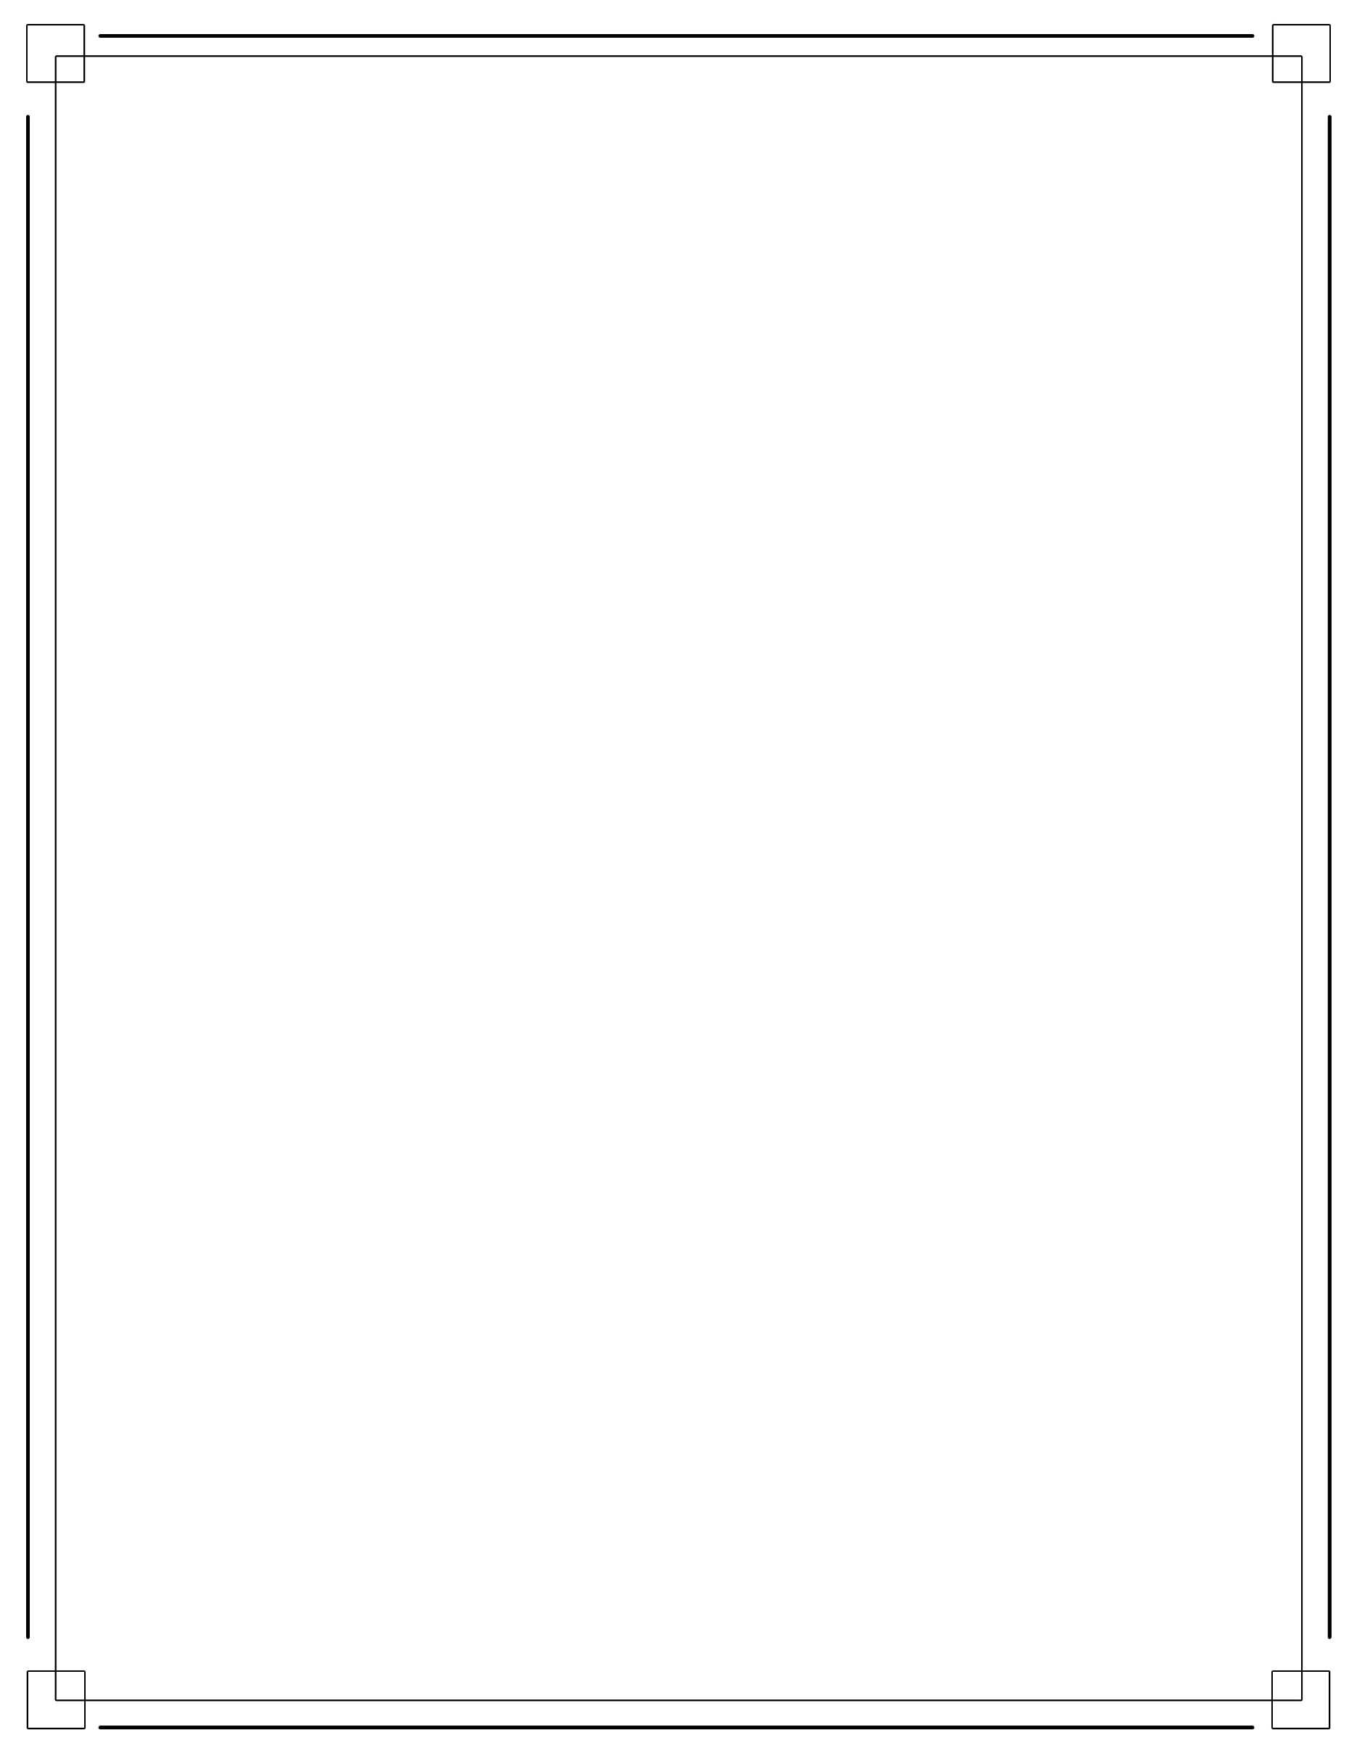University Conference Center System (UCCS)

Executable Release: Compilation/Connection to Cloud SQL

Effective Date: 4/13/15

{Group 2} Systems Engineer

Working-Level Integrated Product Team (WIPT) Executable Release

*Output*

1. Executable Release: Output
2. Goal:
   1. The system will produce the HTML table from PD1 on the conference requested by the user.
   2. View record will also become available
3. Classes to be Implemented:
   1. Record
   2. Conference
4. Previously Implemented Classes to Use:
   1. Session
   2. Conference
5. Use Case to be Implemented:
   1. View Individual Conference Details
   2. View Record
6. Inputs:
   1. User input (Dummy Information)
7. Outputs:
   1. Compilation
   2. Successful generation and presentation of the information requested
8. Release Date:
   1. *4/14/15 11:59 PM*